Homicide Rates in Bedfordshire, England, 1265-1275

Randolph Roth

November 20, 2017

Thanks to the scholarship of R. F. Hunnisett, translations are today available of many coroner’s rolls from medieval and early modern England. One of the most complete is for Bedfordshire, which includes inquests held between 1265 to 1275 in each of the county’s hundreds (the nine regional jurisdictions within the county), and between 1300 to 1305 in the borough of Bedford, which was a jurisdiction separate from the hundreds.

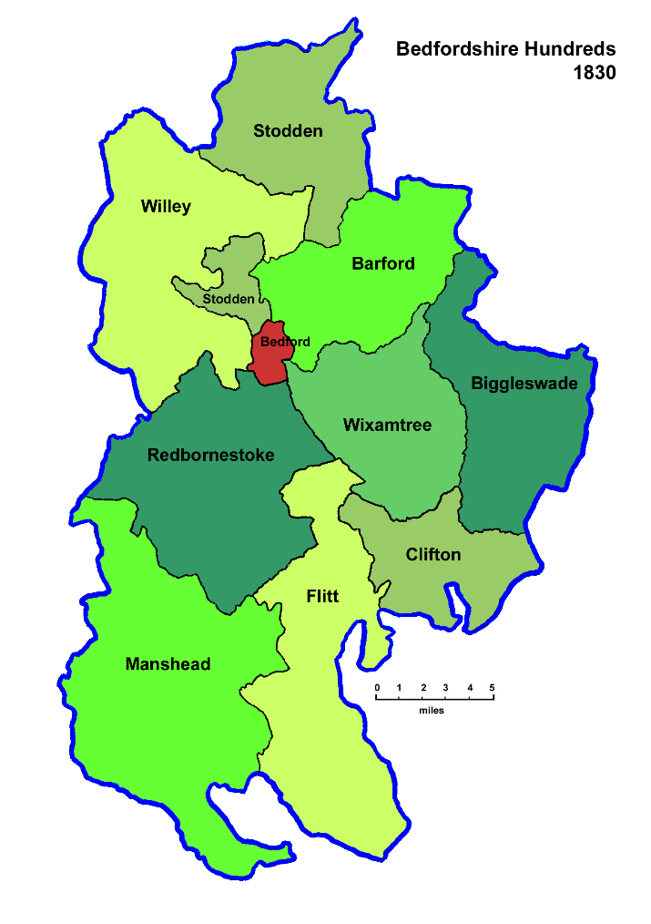

The data are not complete. The coroners for each of the hundreds submitted records for a different number of years between 1265 and 1275, and records of the coroner for Bedford borough have been preserved only for later years. Thus, to get a comprehensive count of homicide victims in Bedfordshire, 1265-1275, it is necessary to extrapolate from the partial records of each hundred to the entire eleven-year period, and to use the data for the borough of Bedford from 1300-1305 as a proxy for the missing borough records from 1265-1275.
To estimate the length of time that each coroner was active, I assumed that each coroner was active a few months before and after their first and last reports. So I estimated the average length of time between inquests reported by each coroner (including inquests on accidents, suicides, and other deaths), and added one average length of the time to the time between the first and last inquests reported. That allowed me to calculate the average number of homicides per year in each hundred and in the borough of Bedfordshire, and to extrapolate from that average to the probable number of homicides in Bedfordshire as a whole, 1265-1275. And using the “Estimates of County and Borough Populations in England, 1200-1589,” I calculated a homicide rate for Bedfordshire for those years.
It turned out that Bedfordshire was far more homicidal than the Eyre Records from the same period would indicate. The coroner’s records contained an estimated 73 percent more reported homicides per year than the Eyre Records, which were supposed to contain a complete record. This means that the Eyre records may understate the homicide rate in medieval England considerably.
The estimated rate for Bedfordshire from the coroner’s records, 1265-1275, is:

Estimated number of homicides 228.4

Population-years at risk 789934

Homicide rate 25.2

The rate from the Eyre records, 1261-1276, was only 16.8 per 100,000 per year.

EXCEL and CSV files

Bedfordshire Coroner’s Rolls HDV 1265-1275 and 1300-1305 from Hunnisett

References

Hunnisett, R. F., ed. (1960) Bedfordshire Coroners' Rolls. Streatley: Bedfordshire.

